Northdown Surgery
2015 December -How are we doing?

We would be grateful if you would complete this survey about our Practice. We want to provide the highest standard of care. A summary from this survey will be fed back to members of the Practice and to patients, to help identify areas for improvement. Your opinions are very valuable. Please answer ALL the questions you can. There are no right or wrong answers and your doctor or nurse will NOT be able to identify your individual answers. Thank you.
Please note that the term "Clinician" covers GPs, Nurse Practitioners, Nurses and Health Care Assistants.

About Your Visit to the Surgery

How good was the Clinician at:
Q1 Putting you at ease?
Very good 46%
Good 26%
Satisfactory 12%
Poor 6%
Very poor 2%
Does not apply 4%
No response 4%
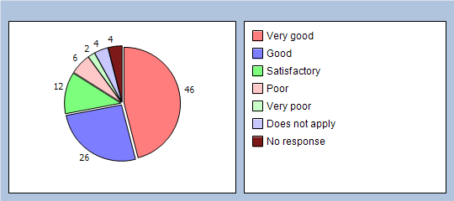

Q2 Being polite and considerate?
Very good 53%
Good 24%
Satisfactory 10%
Poor 5%
Very poor 0%
Does not apply 3%
No response 5%
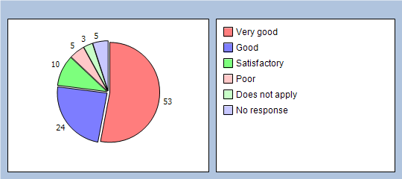

Q3 Listening to you?
Very good 43%
Good 25%
Satisfactory 19%
Poor 0%
Very poor 4%
Does not apply 4%
No response 5%
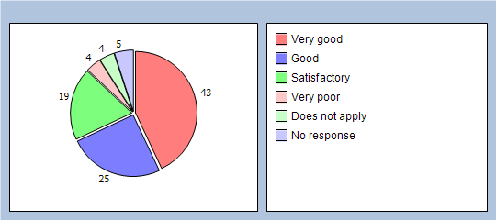

Q4 Giving you enough time?
Very good 41%
Good 23%
Satisfactory 21%
Poor 4%
Very poor 2%
Does not apply 3%
No response 6%
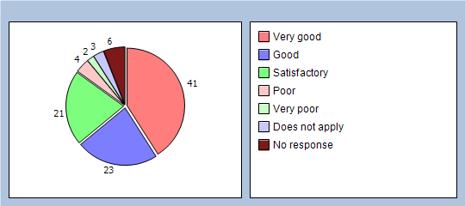

Q5 Assessing your medical condition?
Very good 34%
Good 28%
Satisfactory 17%
Poor 7%
Very poor 2%
Does not apply 6%
No response 6%
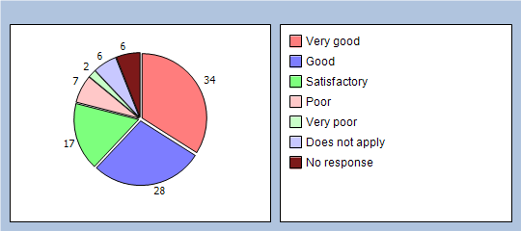

How good was the Clinician at:
Q6 Explaining your condition and treatment?
Very good 32%
Good 28%
Satisfactory 21%
Poor 2%
Very poor 3%
Does not apply 10%
No response 4%
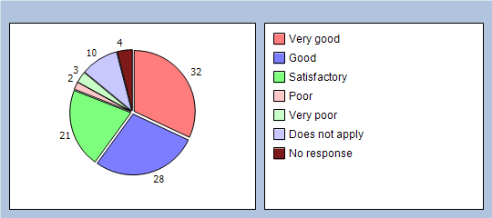

Q7 Involving you in decisions about your care?
Very good 28%
Good 25%
Satisfactory 21%
Poor 5%
Very poor 1%
Does not apply 13%
No response 7%
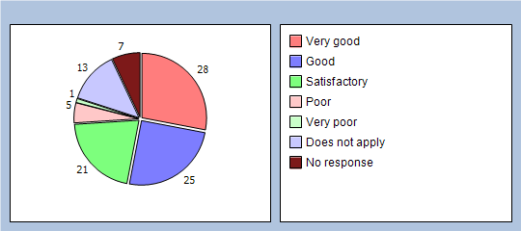

Q8 Providing or arranging treatment for you?
Very good 32%
Good 29%
Satisfactory 13%
Poor 5%
Very poor 0%
Does not apply 15%
No response 6%
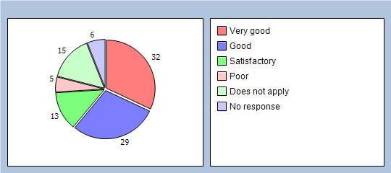

Q9 Did you have confidence that the Clinician is honest and trustworthy?
Yes, definitely 66%
Yes, to some extent 19%
No, not at all 2%
Do not know / can not say 7%
No response 6%
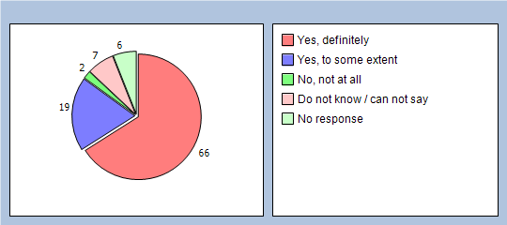

Q10 Did you have confidence that the Clinician will keep your information confidential?
Yes, definitely 68%
Yes, to some extent 12%
No, not at all 1%
Do not know / can not say 12%
No response 7%
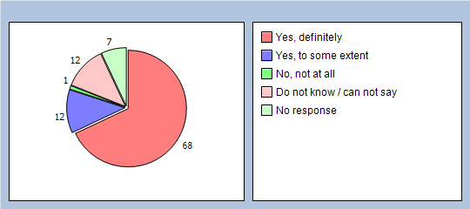

Q11 Would you be completely happy to see this Clinician again?
Yes 82%
No 11%
No response 7%
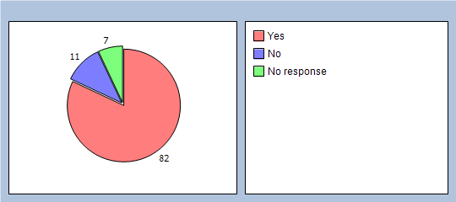
Please enter the name of the Clinician you recently saw and add any additional comments:

About Receptionists and Appointments
Q12 How helpful do you find the Receptionists at our practice?
Very helpful 38%
Fairly helpful 43%
Not very helpful 10%
Not at all helpful 4%
Do not know 1%
No response 4%
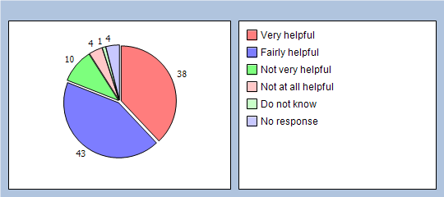

Q13 How easy is it to speak to a doctor or nurse on the phone at our practice?
Very easy 13%
Fairly easy 21%
Not very easy 23%
Not at all easy 19%
Do not know 4%
Have not tried 17%
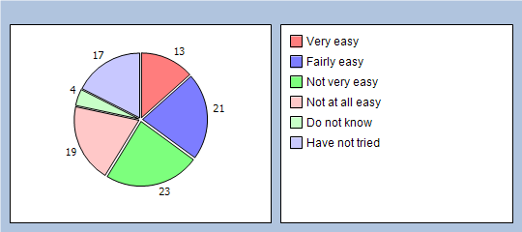

Q14 If you need to see a Clinician urgently, can you normally get seen on the same day?
Yes 37%
No 46%
Do not know / never needed to 15%
No response 2%
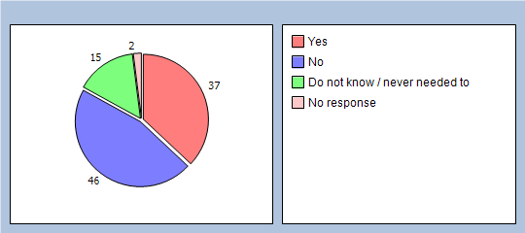

Q15 How do you normally book your appointments at your practice? (please X all boxes that apply)
In person 42%
By phone 69%
Does not apply 4%

Q16 Which of the following methods would you prefer to use to book appointments at your practice? (please X all boxes that apply)
In person 23%
By phone 53%
Online 62%
Does not apply 0%

How quickly do you get to see a specific doctor:
Q17 How quickly do you usually get seen?
Same day or next day 16%
2-4 days 21%
5 days or more 39%
I do not usually need to be seen quickly 10%
Do not know, never tried 8%
No response 6%
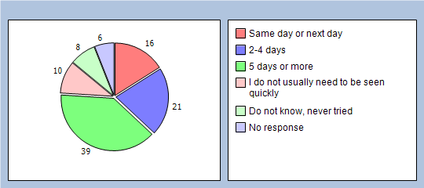

Q18 How do you rate how quickly you were seen?
Excellent 6%
Very good 15%
Good 15%
Satisfactory 32%
Poor 13%
Very poor 7%
Does not apply 4%
No response 8%
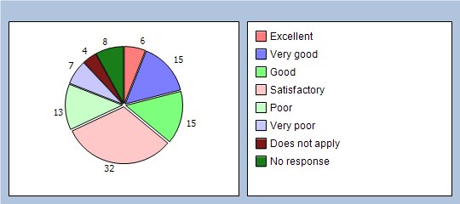

Thinking of times when you are willing to see any doctor:
Q19 How quickly do you usually get seen?
Same day or next day 42%
2-4 days 24%
5 days or more 19%
I do not usually need to be seen quickly 3%
Do not know, never tried 7%
No response 5%
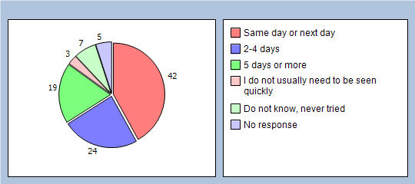

Q20 How do you rate how quickly you were seen?
Excellent 5%
Very good 22%
Good 14%
Satisfactory 28%
Poor 13%
Very poor 7%
Does not apply 5%
No response 6%
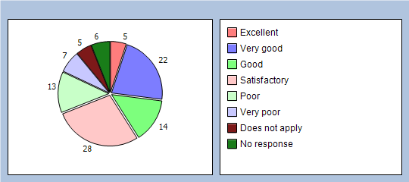

Thinking about the care you get from your doctors and nurses overall, how well does the practice help you to:

Q21 Understand your health problems?
Very well 60%
Unsure 21%
Not very well 12%
Does not apply 3%
No response 4%
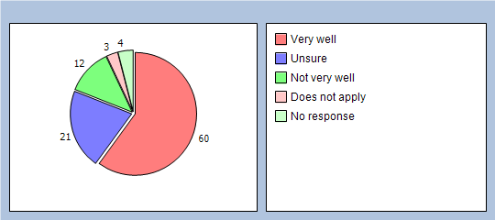

Q22 Cope with your health problems
Very well 56%
Unsure 22%
Not very well 15%
Does not apply 4%
No response 3%
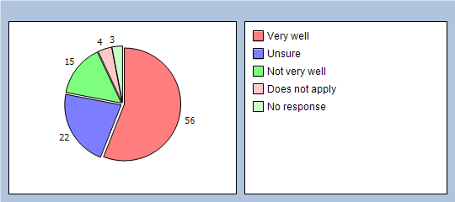
Q23 Keep yourself healthy
Very well 47%
Unsure 23%
Not very well 14%
Does not apply 12%
No response 4%
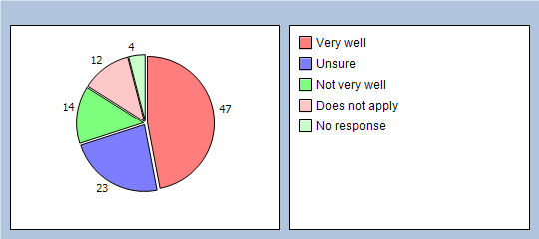

Q24 Overall, how would you describe your experience of our surgery?
Excellent 17%
Very good 23%
Good 21%
Satisfactory 17%
Poor 14%
Very poor 3%
No response 5%
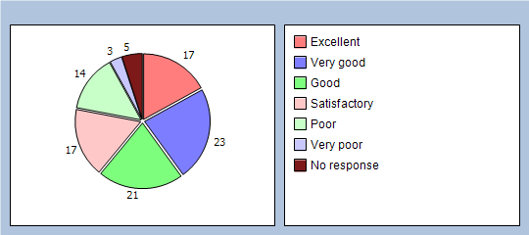

Q25 Would you recommend our surgery to someone who has just moved to your local area?
Yes, definitely 28%
Yes, probably 39%
No, probably not 19%
No, definitely not 8%
Do not know 3%
No response 3%
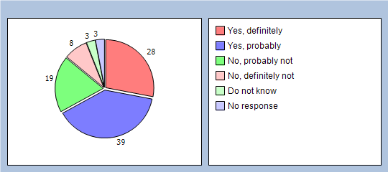

It will help us to understand your answers if you could tell us a little about yourself
Q26 Are you ?
Male 32%
Female 66%
No response 2%
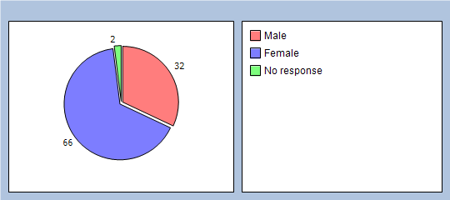

Q27 How old are you?
Under 16 0%
16 to 44 14%
45 to 64 38%
65 to 74 35%
75 or over 10%
No response 3%
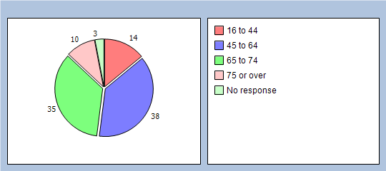

Q28 Do you have a long-standing health condition?
Yes 73%
No 21%
Do not know / can not say 3%
No response 3%
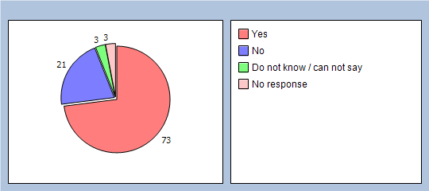

Q29 What is your ethnic group?
White 95%
Black or Black British 0%
Asian or Asian British 0%
Mixed 0%
Chinese 0%
Other ethnic group 0%
No response 5%
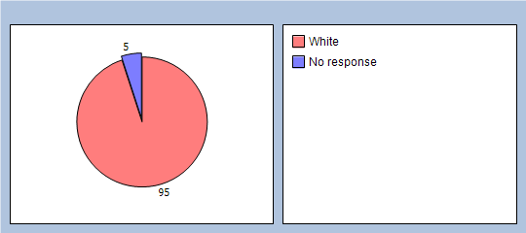

Q30 Which of the following best describes you?
Employed (full or part time, including self-employed) 19%
Unemployed / looking for work 1%
At school or in full time education 0%
Unable to work due to long term sickness 14%
Looking after your home/family 4%
Retired from paid work 53%
Other 3%
No response 6%
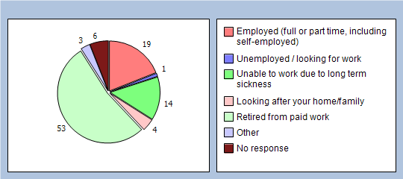

Finally, please add any other comments you would like to make about our Practice:

Comments downloaded:

Re: Appointments:

- Can only guarantee being seen on the same day by going early and queuing. Doctors are good once you see them. One nurse needs to learn to listen to patients, not talk over them.
- Can't get to surgery early in the morning to make an appointment as I have back trouble and can't stand for long. The last four times I've tried to see my doctor all appointments have gone by telephone. In fact I have no confidence in the surgery at all. Prescription not passed to chemist.
- Difficult sometimes to get an appointment by phoning for at least half an hour & then told there are no appointments left that day & having to ring again the next day? My husband has given up on this & visits the surgery first thing early in the day which is not
- Getting an appointment via phone is currently appalling, last time I called 79 times on the first day taking 20 mins to get through only to be told appointments all gone. The following day after calling 85 times same thing .Finally on third day I tried the drop in clinic and sat for an hour and a half before being seen, surgery full 45 people before me to see one person.
- Good treatment generally but can be a bit lax in some things. Expecting people to queue outside in the cold to get appt because they cannot get through on phone is not reasonable. I understand you are working on this though.
- Hard for me to answer a lot of these, I can't phone for an appointment for same day, as I'm either at work, or going to work later in the day. To come in person you need to be at the gates before the crack of dawn as all the non-workers and no hopers have already taken the appointments. You need to make a system that enables people to make appointments in advance by say a couple of days.
- Have had appointment cancelled without being informed until I got to surgery.
- I can usually get an appointment on the same day if I am happy to see a Nurse Practitioner, however, on all occasions I have to phone the surgery constantly from 8.ooam. On the rare times that I have been able to get through quickly I have been told that no appointments are available to see anyone, this has been at 8.10am!! This situation is very concerning for people who do need to see someone but just cannot. Feeling unwell and having the anxiety of trying to get to see someone to help you can be so upsetting and frustrating. Having said all this, I do know that the surgery are looking after so many people with the staff they have available and, overall, do an excellent job of trying to accommodate as many people as they can, but, everyone that needs to be seen should be able to be seen.
- I get seen on the same day because I get up early and queue outside. When I don't do this I have to wait several days. I would not recommend this surgery as we do not have enough doctors to take on more patients.
- I have always had help and advice at Reception. All the medical staff have helped me. Dr. Williams has always been helpful and good with me in all my problems.
- I have been with your Surgery for many years and I am very happy with the treatment I receive
- I have problems which mean I am unable to stand in a queue for an early appointment therefore I must phone. I am never ever able to get through quickly at 8oc AM and usually after ringing for 40 mins or more the appointments are gone ! I then am unable to be seen by a Doctor and am given an appointment to see a Practice Nurse etc. The practice never used to be this way. I have a Colostomy and most of my problems relate to that and I find it difficult to continually see someone different every time.
- I have queued from 7.30 in the morning, was first in the queue and went in an asked for an appointment with my specific doctor. Although the doctor was in that day and although I was first in the queue, I was told she had no appointments left that day. How can this happen? Surely not all appointments are given out for pre-booked appointments. Sometimes trying to get an appointment is a complete nightmare, although everything else to do with this surgery is highly satisfactory.
- I really like this doctors surgery but can never get an appointment even if I phone up on the day
- I would like to be able to book by telephone but know that all appointments will be filled so have to get to surgery before 8 to get an appointment that day
- Is not easy to get an appointment on the same day, unless you come in very early in the morning. Is difficult for people who work or have small kids which they have to drag in with them so early. The phone is always busy and at 9 am, when you actually get through, all appointments are gone. No possibility to book it on next day even if someone is pregnant or need the appt for a child. no everyone misses appts and if someone works need to take a day off from work to see a doctor just for 5 mins... it is only if someone has a condition such as diabetes,heart problems etc they can book the appt in advance which I understand but honestly...
- Just the fact that making an appointment is a bit trying, having to phone in the morning before 8.30 and usually being told that all appts have been taken. If you want to see a specific doctor you can't book an appt with them, you are told to phone up each day and hope to get an appt with them but most unlikely, so see different doctors most of the time.
- Last time i took my son to Gp and he even didn't look at my sons finger even.im so so unhappy with this practice.I never can't get appointment
- Make it easier to make appointments as I find it hard to. I come into the surgery to make one for a week or 2 weeks time and I'm always told I can't as I have to call on the morning but I don't have no mean to do so, or I'm told to come in in the morning, but I have to care for my Dad so it's impossible for me to do so. I can't get no appointments so it needs to be made easier.
- Most frustrating trying to get an appointment & always seeing a different doctor as they all have their own views on things and dont always agree with patients treatment
- Overall I am happy with the care I receive but if I need to see a Doctor urgently, I despair of ever getting through on the phone and usually am told when I finally make contact that there are no more appointments for that day, this is after I have been on the phone continuously since opening at 8am. Don't know how this problem can be rectified but I wish it could
- Please make it easier to book appointments in advance online, it's not easy to book an appointment as I work sometimes 8.30am until 7pm so have trouble calling the surgery
- Re: need to see a clinican urgently can you normally get seen on same day - only on drop in days. To see a doctor - no chance. Re: how quickly do you usually get seen? It is almost impossible to book to see a preferred doctor. Nearly always fuly booked on the day - no forward booking.
- Standing in the rain to book an appointment is not acceptable in a modern society. The phones are not answered when booking an appointment in the mornings.
- Taking far too long to book blood test appointments if needed at surgery (3 weeks sometimes).
- The GPs are great, but usually difficult to book appointment. Nurse practitioner appointments are not always good for one with longstanding conditions in the background

Re: Telephone system:

- I would like to be able to book by telephone but know that all appointments will be filled so have to get to surgery before 8 to get an appointment that day
- More dedicated phone lines in the morning to be able to book appointment would be helpful, as by the time you get through all appointments are gone. Also not being able to pre book an appointment with a specific doctor in advance with the receptionist and being told to phone on the specific day meaning the above.
- Would prefer doctors to nurse practitioners, some of them have a bad attitude. Can't get through by phone so book in person How quickly do you usually get seen - answer-depends on the doctor
- Overall I am happy with the care I receive but if I need to see a Doctor urgently, I despair of ever getting through on the phone and usually am told when I finally make contact that there are no more appointments for that day, this is after I have been on the phone continuously since opening at 8am. Don't know how this problem can be rectified but I wish it could. I like the online booking system, that is fine if you are not in a hurry to see a Doc.
- Telephone service could be improved
- Telephone service needs to be improved
- the phone in system could be better like a number in a queue worked a lot better that it does now

Re: Staff and Services offered
Negative
- Doctors and Nurses are brilliant - Receptionists are slow at answering, rude, dismissive not at all helpful. As the first point of contact they make the practice look poor.
- Awful surgery. Nurse laughed at my condition
- I don't have any confidence seeing a nurse practitioner
- I find any note added to prescription requests are not read and followed either online or paper version
- Reception staff let the surgery down, quite rude and unsympathetic and gave my results out without my permission.
- Some receptionists are really polite and helpful. Others are rude, abrasive and not at all discreet or understanding
- Some HCA's can't take blood properly. I am an ex-nurse.
- polite and understanding receptionists who do not ignore you would be a vase improvement I have been in the queue and been ignored...."I won’t be a moment" would help !!
- reception need to deal with and move people on quicker..i waited nearly 10 mins while one woman spoke to a patient she knew about the weather, his family etc etc before asking what he was there for. There was no-one else in the reception area and no-one else behind ever hurries to deal with anything either..Very poor
- Was prompted to do this survey today after hearing a receptionist speak sarcastically to someone, which reminded me of similar incidents I have had
- Proves to me that the electronic system cannot be relied upon so in future will check with Reception but as they were busy chose to use the electronic one, which I used previously without any problem
- My remarks are based only on my PRESENT condition. Prior to this I was very happy with Northdown Surgery. However, there have been so many changes that it is impossible to establish any relationship with a particular doctor. Your question (17) should have provided for "not at all" in the answer. One is told categorically that it is impossible to see a doctor of my choice
- Waiting room space is hopeless for wheelchairs/walkers/buggies at busy times. Nowhere to put them.
- Several sets of chairs cannot see the LED board that tells you it's your turn to be seen.
- Disabled parking is a joke.
- Most doctors are running late, in my experience running 15/20 late with the time. Sorry to be negative but you have asked
Positive
- Dr Wolny - a wonderful addition to the practice
- As a new patient, I have been thankful and impressed with your service. Long may it continue, although I will try to stay away as much as possible! God bless you all.
- Dr Williams is always very good Also your new practice nurse, Clare Heatley is very nice - efficient but friendly
- Certainly the Asthma Nurse Natalie Rouse was most helpful and explained problems clearly and concisely and took her job most seriously. I still have to make up my mind about Mr. Cornforth
- Dr Williams is the best doctor I have ever had
- Find all the staff at Northdown Surgery extremely helpful and friendly.
- I appreciate all the hard work the doctors do to keep me healthy. Thank you all.
- Dr Geevarghese is brilliant.
- I have always had help and advice at Reception. all the medical staff have helped me. Dr Williams has always been helpful and good with me in all my problems.
- I have been with your Surgery for many years and I am very happy with the treatment I receive
- It has been steadily been improving. On line appointments very good. Health education videos should continue and be expanded
- My wife and I have been patients at Northdown Surgery for the past 15 years and have always received first class treatment from all the staff at the surgery.
- Ok
- Saw Robina Forrest - I do like the fact she asks if I/we would like antibiotics etc. but feel like she can be uncertain
- Your male receptionist is extremely helpful and has always followed up any queries.
- Both your nurse practitioners are very good. Thank you for providing a reliable service
- The nurse-practitioner clinics are a brilliant idea. A lot of ailments are minor but worrying and it's really helpful to get advice and reassurance without troubling a doctor. I don't mind waiting because I'm retired. If I were working this might be a problem though.
- All the staff are very nice and friendly
- I like the online booking system, that is fine if you are not in a hurry to see a Doc

Re: Miscellaneous comments/suggestions
- The door handle, on the inside of the smaller of the two patient toilets, needs 2 more screws
- I do not like to stand in the queue if it is raining - you could at least open the doors. You could have a machine that gives tickets out like the hospital blood system
- I do have severe Arthritis, but I do not count that as a health condition
- I would like to see more improvement especially after Fiona left and Sorry to say I am glad she left
- You need to make a system that enables people to make appointments in advance by say a couple of days
- I am unhappy with the walk-in clinic arrangements for opening at 10.00 am. I was early along with many others and waiting for the receptionist to call us over to book in. There was no order to this and people just arriving got to the counter first and were seen by the clinician before those who had been waiting. I ended up waiting an hour to be seen when I should have been one of the first. You must think of a fairer way to book in when first opening at 10.00 am. A fairer way would be to allow people to take a numbered ticket on their arrival for this clinic to save on the mad rush to the counter.
- Another point I would like to make would be to have a foot clinic at the surgery from time to time so patients can get treatment. A visiting Podiatrist similar to at other surgeries would be beneficial as waiting 6 months for an appointment at the College Road clinic is just far too long
- More dedicated phone lines in the morning to be able to book appointment would be helpful, as by the time you get through all appointments are gone
- not being able to pre book an appointment with a specific doctor in advance with the receptionist and being told to phone on the specific day meaning the above
- the phone in system could be better like a number in a queue worked a lot better that it does now

